INTERNSHIP REPORT
Batch 7
Tanmay Hirodkar
Infosys Springboard Internship
FWI Prediction

Index
Index 1
CHAPTER 1: INTRODUCTION 2
CHAPTER 2: LITERATURE REVIEW 5
CHAPTER 3: SYSTEM ARCHITECTURE 8
CHAPTER 4: DATASET DESCRIPTION 12
CHAPTER 5: DATA CLEANING & PREPROCESSING 16
CHAPTER 6: EXPLORATORY DATA ANALYSIS (EDA) 23
CHAPTER 7: MACHINE LEARNING MODEL DEVELOPMENT 35
CHAPTER 9: RESULTS AND OUTPUT ANALYSIS 63
CHAPTER 10: APPLICATIONS AND FUTURE SCOPE 67
CHAPTER 11: CONCLUSION 70

CHAPTER 1: INTRODUCTION

1.1 Background of Forest Fires
Forest fires are among the most severe natural disasters affecting ecosystems, human settlements, and climate stability. Every year, large forest areas are destroyed due to uncontrolled fires, leading to loss of biodiversity, air pollution, economic damage, and threats to human life. Climate change, prolonged droughts, rising temperatures, and changing weather patterns have significantly increased the frequency and intensity of forest fires worldwide.
Traditional fire detection systems often rely on manual observation or satellite imagery, which may detect fires only after ignition has occurred. Therefore, predicting fire risk before ignition is essential for early warning, disaster preparedness, and preventive action.
To address this need, meteorological indicators are used to assess fire danger levels. One such widely accepted metric is the Fire Weather Index (FWI), which estimates fire intensity based on weather and fuel conditions.

1.2 Fire Weather Index (FWI)
The Fire Weather Index (FWI) is a numerical indicator used internationally to estimate the potential severity of forest fires. It is part of the Canadian Forest Fire Weather Index System and combines several environmental and weather parameters to produce a final fire danger score.
FWI is influenced by:
- Temperature
- Relative Humidity
- Wind Speed
- Rainfall
- Fuel moisture conditions
The index helps authorities understand how easily a fire may ignite, how fast it may spread, and how difficult it may be to control. Higher FWI values indicate more dangerous fire conditions.

1.3 Problem Statement
Despite the availability of weather data, many regions lack an automated, intelligent system that can:
- Analyze weather conditions
- Predict Fire Weather Index accurately
- Classify fire risk levels
- Provide realtime predictions in a userfriendly manner
Manual analysis of large datasets is timeconsuming and errorprone. Traditional statistical approaches may fail to capture complex relationships among correlated environmental variables. Hence, there is a need for a machine learning based system that can efficiently process meteorological data and predict fire risk accurately.

1.4 Objectives of the Project
The primary objectives of the Tempest – FWI Predictor project are:
- To clean and preprocess raw forest fire weather data.
- To perform exploratory data analysis (EDA) for understanding feature distributions and relationships.
- To build a machine learning model capable of predicting Fire Weather Index.
- To handle multicollinearity among environmental features using regularized regression.
- To classify fire risk levels based on predicted FWI values.
- To deploy the trained model using a Flask based web application.
- To provide a realtime, interactive prediction system for end users.

1.5 Scope of the Project
The scope of this project includes:
- Analysis of historical fire weather data.
- Prediction of fire danger using machine learning techniques.
- Deployment of the predictive model as a web application.
The system is designed for:
- Educational and research purposes
- Early fire risk assessment
- Demonstration of end to end machine learning deployment
The project does not focus on realtime sensor integration or satellite imagery but can be extended in future work.

1.6 Tools and Technologies Used
Category | Tools / Technologies
Programming Language | Python
Data Analysis | Pandas, NumPy
Visualization | Matplotlib, Seaborn
Machine Learning | ScikitLearn
Model Type | Ridge Regression
Feature Scaling | StandardScaler
Web Framework | Flask
Frontend | HTML, CSS, JavaScript

CHAPTER 2: LITERATURE REVIEW

2.1 Introduction
A literature review provides an understanding of existing research, methodologies, and technologies related to a specific problem domain. In the context of forest fire prediction, various traditional, statistical, and machine learning based approaches have been proposed to estimate fire risk and fire intensity.
This chapter reviews existing fire prediction systems, Fire Weather Index based studies, and the growing role of machine learning in climate and disaster prediction. The purpose of this review is to identify the limitations of existing approaches and justify the need for the proposed machine learning based Fire Weather Index predictor.

2.2 Traditional Forest Fire Prediction Methods
Traditionally, forest fire prediction and monitoring relied on:
- Manual observation by forest officials
- Watch towers and patrol teams
- Historical fire records
- Basic weather condition thresholds
These methods were highly dependent on human judgment and were often reactive rather than preventive. Fires were usually detected after ignition, which resulted in delayed response and increased damage.
Limitations of traditional methods:
- High dependency on human observation
- Slow response time
- Inability to analyze large datasets
- Lack of predictive intelligence

2.3 Fire Weather Index (FWI) Based Systems
The Fire Weather Index (FWI) system was introduced to provide a standardized and scientific method for estimating fire danger. It uses meteorological variables such as temperature, humidity, rainfall, and wind speed along with fuel moisture codes to compute a numerical fire danger value.
Several studies have shown that:
- Higher FWI values correlate strongly with severe fire incidents
- FWI is effective in estimating fire spread and intensity
- Moisture indices like FFMC, DMC, and DC play a crucial role
However, most traditional FWI calculations are:
- Rulebased
- Static
- Not adaptive to changing climate patterns
This creates scope for machine learning models that can learn complex, nonlinear relationships between variables.

2.4 Machine Learning in Fire Risk Prediction
With advancements in data science, machine learning techniques have been widely applied in environmental and climate studies. Researchers have explored various algorithms such as:
- Linear Regression
- Logistic Regression
- Decision Trees
- Random Forest
- Support Vector Machines
- Neural Networks
Machine learning models can:
- Learn patterns from historical data
- Handle multiple correlated variables
- Provide more accurate predictions
- Adapt to changing data trends
Studies show that regressionbased models perform well for predicting continuous fire danger indices like FWI.

2.5 Role of Regression Models
Regression models are widely used when the target variable is continuous. In fire prediction:
- Fire Weather Index is a continuous numerical value
- Weather features are often correlated
Simple linear regression may fail due to multicollinearity, where independent variables are highly correlated with each other.
To address this issue, regularized regression models such as Ridge Regression are preferred.

2.6 Ridge Regression in Environmental Studies
Ridge Regression is an extension of linear regression that applies L2 regularization to reduce overfitting and stabilize model coefficients.
Advantages of Ridge Regression:
- Handles multicollinearity effectively
- Prevents large coefficient values
- Produces stable and reliable predictions
- Suitable for climate and weather data
Many environmental prediction studies recommend Ridge Regression when:
- Dataset contains correlated variables
- Overfitting needs to be controlled
- Interpretability is required
This makes Ridge Regression a suitable choice for predicting Fire Weather Index.

2.7 Limitations of Existing Systems
Despite existing research, several limitations remain:
- Many systems focus only on data analysis, not deployment
- Lack of realtime prediction capability
- Absence of userfriendly interfaces
- Limited integration of ML models with web applications
- Static prediction methods without scalability
These limitations highlight the need for an endtoend solution combining data preprocessing, machine learning, and deployment.

2.8 Motivation for the Proposed System
The motivation behind this project is to overcome the shortcomings of existing systems by:
- Building a complete ML pipeline
- Using Ridge Regression to handle correlated features
- Providing accurate Fire Weather Index prediction
- Deploying the model as an interactive web application
- Enabling realtime fire risk assessment
The proposed system aims to convert raw meteorological data into meaningful predictions that can assist in early fire warning and decision making.

2.9 Summary of Literature Review
This chapter reviewed traditional fire detection methods, Fire Weather Indexbased systems, and machine learning approaches used in forest fire prediction. While previous research establishes the importance of FWI and weather parameters, there is a clear gap in terms of practical deployment and intelligent prediction systems.
The insights gained from this literature review form the foundation for the proposed Tempest – FWI Predictor, which integrates data science and web technologies to create a realworld applicable solution.

CHAPTER 3: SYSTEM ARCHITECTURE

3.1 Introduction
System architecture defines the overall structure of the proposed Fire Weather Index (FWI) prediction system. It explains how different components such as data preprocessing, machine learning model, and web application interact with each other to produce accurate fire risk predictions.
The Tempest – FWI Predictor is designed as an endtoend machine learning system, starting from raw data processing to realtime prediction through a web interface. This modular architecture ensures scalability, maintainability, and ease of deployment.

3.2 Overall System Architecture
The system is divided into four major layers:
- Data Layer
- Processing & Analysis Layer
- Machine Learning Layer
- Application & User Interface Layer
Each layer performs a specific role and communicates with adjacent layers.

3.2.1 HighLevel Architecture Diagram
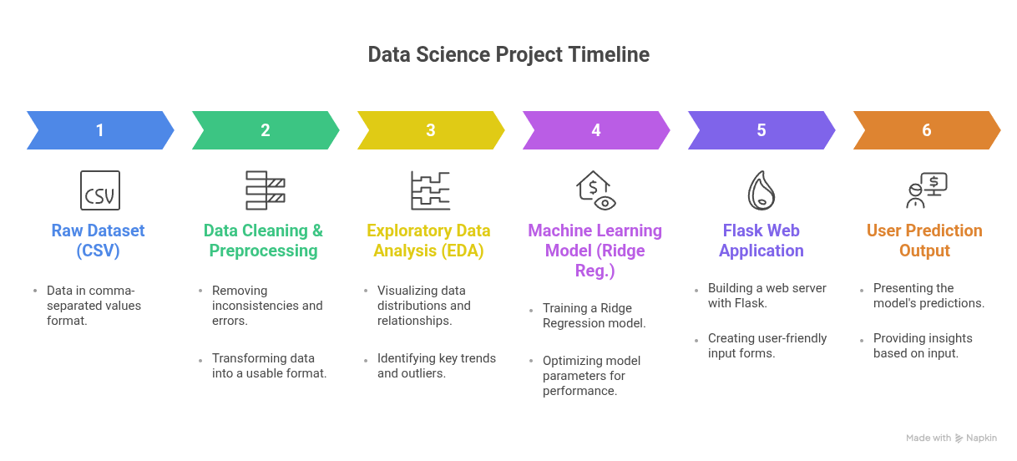

3.3 Data Flow Architecture
Data flow architecture explains how data moves through the system from input to output.

3.3.1 Data Flow Steps
- Raw fire weather data is loaded from CSV files.
- Data cleaning and preprocessing are applied.
- Cleaned data is analyzed using EDA techniques.
- Selected features are passed to the machine learning model.
- Trained model is saved and deployed.
- User inputs weather parameters via web interface.
- Model predicts FWI and fire risk level.
- Results are displayed to the user.

3.3.2 Data Flow Diagram

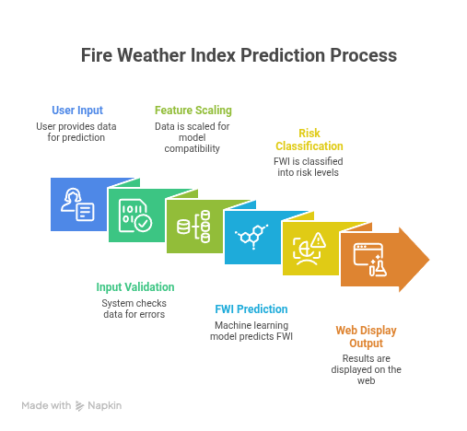

3.4 Machine Learning Pipeline Architecture
The machine learning pipeline is the core of the system. It ensures that data is correctly prepared, trained, evaluated, and reused during deployment.

3.4.1 ML Pipeline Components
- Data Loading
- Feature Selection
- TrainTest Split
- Feature Scaling
- Model Training
- Model Evaluation
- Model Saving

3.4.2 ML Pipeline Flowchart
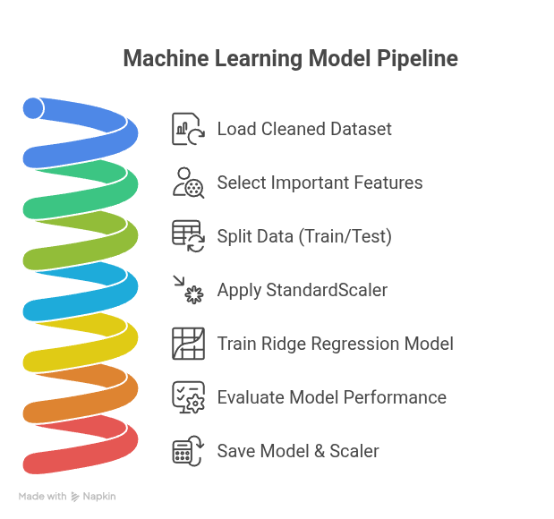

3.5 Web Application Architecture
The web application acts as the interface between the user and the machine learning model. Flask is used as the backend framework due to its simplicity and efficiency.

3.5.1 Web Architecture Components
- Frontend:
HTML, CSS, JavaScript for user input and visualization
- Backend:
Flask server handling requests and predictions
- Model Layer:
Trained Ridge Regression model and scaler files

3.5.2 Web Application Flow Diagram
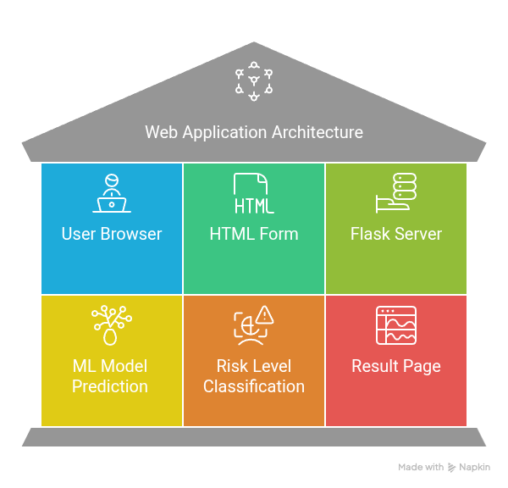

3.6 ModuleWise Architecture Description

3.6.1 Data Preprocessing Module
- Handles missing values
- Converts data types
- Encodes target labels
- Produces clean dataset
3.6.2 Analysis Module
- Generates histograms
- Produces correlation heatmaps
- Helps in feature selection

3.6.3 Prediction Module
- Loads trained ML model
- Scales input data
- Predicts FWI value
- Classifies fire risk
3.6.4 User Interface Module
- Accepts user inputs
- Displays predictions
- Shows risk levels visually
3.7 Advantages of the Proposed Architecture
- Modular and scalable design
- Easy integration of new models
- Separation of concerns
- Realtime prediction capability
- Userfriendly interface

CHAPTER 4: DATASET DESCRIPTION

4.1 Introduction
The quality and structure of a dataset play a crucial role in the performance of any machine learning model. For the Tempest – Fire Weather Index (FWI) Predictor, a comprehensive forest fire weather dataset containing meteorological and fire index parameters was utilized. This dataset forms the backbone of the predictive system, enabling accurate estimation of fire danger levels based on environmental conditions.
This chapter provides a detailed description of the dataset used in the project, including its source, structural characteristics, feature descriptions, target variables, and the challenges encountered during the initial analysis phase. Understanding these aspects is essential for designing an effective preprocessing pipeline and selecting an appropriate machine learning model.

4.2 Source of Dataset
The dataset employed in this project comprises historical forest fire weather observations collected over multiple days from forest monitoring systems. It contains a rich combination of meteorological measurements and derived fire indices that are widely recognized and utilized in fire risk estimation and management systems worldwide.
The dataset is stored in CSV (Comma Separated Values) format, which provides several advantages including ease of processing using Python-based data analysis libraries such as Pandas, compatibility across different platforms, and straightforward integration with machine learning frameworks. The structured nature of the CSV format allows for efficient data manipulation and transformation operations.

4.3 Structure of the Dataset
The dataset follows a tabular structure where each row represents a single day's fire weather observation, while each column represents a specific weather parameter or fire index attribute. This organization facilitates temporal analysis and pattern recognition across different environmental conditions.
Dataset Characteristics:
- Data Type: Tabular
- Format: CSV (Comma Separated Values)
- Nature: Structured numerical and categorical data
- Records: Daily observations spanning multiple temporal periods
- Features: Combination of numerical meteorological parameters and categorical fire classifications
- Organization: Row-wise daily observations with column-wise attributes

4.4 Feature Description
The dataset encompasses a comprehensive set of features that capture both direct meteorological measurements and derived fire behavior indices. These features are organized into distinct categories based on their nature and purpose.

4.4.1 Meteorological Features
The primary meteorological features directly measure environmental conditions that influence fire ignition and spread behavior:
Feature Name | Description | Unit | Range
Temperature | Ambient air temperature | °C | Variable
RH | Relative humidity of air | % | 0-100
Ws | Wind speed | km/h | ≥0
Rain | Rainfall amount | mm | ≥0
These parameters are fundamental drivers of fire behavior. Temperature and wind speed promote fire ignition and spread, while relative humidity and rainfall act as suppressing factors. The interplay between these variables determines the overall fire risk at any given time.

4.4.2 Fire Weather Indices
The dataset includes several standardized fire weather indices that quantify different aspects of fire danger. These indices are derived from meteorological data using established fire weather systems:
Feature Name | Description | Fire Aspect Measured
FFMC | Fine Fuel Moisture Code | Moisture content of surface litter and fine fuels
DMC | Duff Moisture Code | Moisture level of decomposed organic matter
DC | Drought Code | Long-term cumulative moisture deficit
ISI | Initial Spread Index | Expected rate of fire spread
BUI | Buildup Index | Fuel availability and consumption potential
FWI | Fire Weather Index | Overall fire danger rating
These indices collectively provide a comprehensive assessment of fire weather conditions. The FFMC, DMC, and DC represent different fuel moisture layers, while ISI and BUI capture fire behavior characteristics. The FWI serves as an integrated measure combining multiple factors into a single fire danger rating.

4.4.3 Target Variable
The dataset includes two target variables that serve different analytical purposes:
Continuous Target:
- FWI (Fire Weather Index): A continuous numeric value indicating the overall fire danger level. Higher values represent greater fire danger and potential for destructive fires.
Categorical Target:
- Classes: A binary categorical outcome with two possible values:
  - fire – Indicates conditions conducive to fire occurrence
  - not fire – Indicates conditions with minimal fire risk
For machine learning purposes, the categorical Classes column is encoded into binary numerical values to enable computational processing:
- fire → 1
- not fire → 0
This binary encoding transformation is essential for classification algorithms and allows the model to learn patterns distinguishing fire-prone from non-fire-prone conditions.

4.5 Temporal Attributes
The dataset incorporates temporal attributes that provide chronological context to the observations:
- Day: Day of the month (1-31)
- Month: Month of the year (1-12)
- Year: Calendar year of observation
These temporal attributes are valuable for identifying seasonal patterns, long-term trends, and cyclical variations in fire weather conditions. However, they were excluded from the final model training phase because they do not directly influence fire intensity prediction in a mechanistic sense. The environmental conditions captured by meteorological and fire index features provide more direct predictive information than temporal markers alone.

4.6 Data Challenges Identified
During the initial inspection and exploratory phase of the dataset, several data quality challenges were identified that required systematic resolution before model development:
- Missing Values: Certain numeric columns contained missing or null entries, which could disrupt model training and lead to biased predictions.
- Data Type Inconsistencies: Some numeric values were incorrectly stored as string (object) data types due to formatting irregularities or the presence of special characters during data collection.
- Class Label Formatting Issues: The categorical class labels exhibited inconsistent formatting including:
  - Extra leading or trailing whitespace
  - Inconsistent capitalization (uppercase, lowercase, mixed case)
  - Variations in spelling or representation
- Feature Correlation: Preliminary analysis revealed the presence of highly correlated features, indicating potential multicollinearity that could affect regression model stability.
- Outliers and Anomalies: Certain observations contained extreme values that required investigation to determine whether they represented genuine environmental extremes or data collection errors.
These challenges necessitated a comprehensive data cleaning and preprocessing pipeline to transform the raw dataset into a machine-learning-ready format. Addressing these issues was critical for ensuring model reliability and prediction accuracy.

4.7 Importance of Dataset for the Project
This dataset is exceptionally well-suited for the Tempest FWI Predictor project for several compelling reasons:
Real-World Relevance: The dataset contains authentic environmental data collected from actual fire weather monitoring systems, ensuring that the model learns from realistic conditions rather than synthetic or simulated data.
Comprehensive Feature Coverage: The inclusion of both primary meteorological measurements and derived fire indices provides multiple perspectives on fire danger, enabling the model to capture complex relationships between environmental factors and fire behavior.
Regression Compatibility: The continuous nature of the FWI target variable makes the dataset ideal for regression-based prediction, allowing for precise quantification of fire danger levels rather than simple binary classification.
Behavioral Realism: The patterns and relationships present in the dataset reflect established fire weather science, ensuring that model predictions align with domain knowledge and physical principles.
The dataset serves as the foundation for multiple critical project components:
- Exploratory Data Analysis (EDA): Understanding patterns, distributions, and correlations
- Feature Selection: Identifying the most informative predictors
- Model Training: Learning the relationship between inputs and fire danger
- Model Evaluation: Assessing prediction accuracy and generalization
- Web-Based Prediction System: Enabling real-time fire danger estimation

CHAPTER 5: DATA CLEANING & PREPROCESSING

5.1 Introduction
Real-world datasets are rarely clean and ready for direct use in machine learning models. Environmental and climate datasets, in particular, frequently contain missing values, inconsistent data types, measurement noise, and irregular formatting issues that arise during data collection and storage processes. If such problematic data is used directly without proper cleaning and preprocessing, it inevitably leads to inaccurate predictions, poor model performance, and unreliable results.
Therefore, before performing statistical analysis or training machine learning models, it is essential to apply systematic data cleaning and preprocessing techniques. These techniques transform raw, messy data into a clean, consistent, and machine-learning-ready format that enables algorithms to learn meaningful patterns effectively.
This chapter explains in detail the comprehensive methods and techniques used to prepare the raw forest fire weather dataset for subsequent analysis and modeling phases. Each preprocessing step is justified and explained with its specific purpose and implementation approach.

5.2 Need for Data Cleaning
The raw dataset used in this project exhibited several significant issues that required systematic resolution:
Data Quality Issues:
- Missing Values: Several numeric columns contained null or missing entries that could cause computational errors or introduce bias
- Type Inconsistencies: Numeric values were incorrectly stored as strings (object type) due to formatting irregularities
- Label Formatting: Class labels showed inconsistent formatting with mixed capitalization and extra whitespace
- Irrelevant Attributes: Certain columns did not contribute to fire intensity prediction and added unnecessary complexity
Consequences of Unprocessed Data:
If these issues are not properly addressed, several problems arise:
- Machine learning algorithms may fail to train or produce errors
- Predictions become biased or systematically incorrect
- Model accuracy and reliability are significantly reduced
- Results cannot be trusted for real-world decision-making
Hence, a structured and comprehensive preprocessing pipeline was designed and implemented to ensure data quality and model reliability.

5.3 Data Loading
The initial step involved loading the dataset into a suitable data structure for manipulation and analysis. The Pandas library in Python was used as it provides efficient data structures and an extensive collection of functions for data manipulation and analysis.
python
import pandas as pd
# Load the dataset from CSV file
df = pd.read_csv("ff2.csv")
After loading the dataset, preliminary inspection was performed to understand its structure, identify data types, and detect missing values:
python
# Display first few rows
df.head()
# Display dataset information including data types
df.info()
# Count missing values in each column
df.isnull().sum()
This initial inspection revealed the extent of data quality issues and informed the design of subsequent preprocessing steps.

5.4 Data Type Conversion
During inspection, several numeric columns were found to be stored as object (string) data types. This occurred due to the presence of invalid characters, inconsistent formatting, or mixed data types within columns during data collection or storage.
Resolution Approach:
All columns expected to contain numeric values were explicitly converted to numeric data type using the pd.to_numeric() function with error handling:
python
for col in numeric_columns:
df[col] = pd.to_numeric(df[col], errors='coerce')
Key Parameters:
- errors='coerce': Invalid entries that cannot be converted to numbers are automatically converted to NaN (Not a Number), allowing the process to continue without errors

Benefits:
- Ensures all numerical features are in a consistent numeric format
- Enables mathematical operations and statistical computations
- Prepares data for machine learning algorithms that require numeric input

5.5 Handling Missing Values
Missing values represent a common and significant challenge in real-world datasets. They can arise from sensor failures, data transmission errors, incomplete records, or measurement impossibilities. Missing values negatively impact model learning by reducing available information and potentially introducing bias.
Strategy Selection:
Rather than simply dropping rows containing missing values, which would result in substantial information loss, a mean imputation strategy was adopted.
Mean Imputation Approach:
Missing values in numeric columns were replaced with the mean (average) of the respective column:
python
# Fill missing values with column means
df.fillna(df.mean(), inplace=True)
Advantages of Mean Imputation:
- Preserves the overall distribution and statistical properties of the data
- Maintains dataset size, preventing information loss
- Provides reasonable estimates for missing environmental measurements
- Simple to implement and computationally efficient
Result:
This step ensured that the dataset was complete with no missing values, making it suitable for further analysis and model training.

5.6 Cleaning Categorical Class Labels
The Classes column, which contains the categorical target variable, exhibited several formatting inconsistencies that required standardization:
Identified Issues:
- Extra leading or trailing whitespace characters
- Inconsistent capitalization (e.g., "Fire", "fire", "FIRE")
- Variations that would be treated as distinct categories despite having the same meaning

Standardization Process:
A multi-step cleaning process was applied:
python
df['Classes'] = df['Classes'].astype(str).str.strip().str.lower()
Steps Breakdown:
- Convert to String: Ensures all values are treated as text
- Strip Whitespace: Removes leading and trailing spaces using .str.strip()
- Convert to Lowercase: Standardizes capitalization using .str.lower()
Outcome:
This process ensured uniform class representation with only two distinct values: "fire" and "not fire". Standardization eliminated spurious categories and enabled proper encoding in subsequent steps.

5.7 Encoding the Target Variable
Machine learning algorithms operate on numerical data and require numeric input features and output targets. Therefore, the categorical class labels needed to be converted into binary numerical values through encoding.
Encoding Scheme:
Class Label | Encoded Value | Interpretation
fire | 1 | Fire condition present
not fire | 0 | No fire condition
Implementation:
python
df['Classes_binary'] = df['Classes'].map({'fire': 1, 'not fire': 0})
Purpose:
This binary encoding transformation:
- Prepares the target variable for classification and regression tasks
- Enables computational processing of categorical outcomes
- Maintains semantic meaning (1 represents presence, 0 represents absence)
- Facilitates model training and evaluation
The newly created Classes_binary column serves as the target variable for classification models, while the original Classes column can be retained for reference purposes.

5.8 Feature Selection and Column Removal
Not all columns in the dataset contribute equally to fire intensity prediction. Certain columns were identified as non-contributory and were removed before model training to improve efficiency and reduce noise.
Columns Removed:
- day, month, year: Temporal attributes that do not directly influence fire intensity in a mechanistic sense
- Classes: Original categorical column (redundant after binary encoding)
Rationale:
- Temporal attributes represent when observations occurred but do not capture the environmental conditions that cause fires
- The encoded binary version (Classes_binary) contains the same information as the original Classes column in a model-compatible format
- Removing redundant and non-predictive features reduces dimensionality and improves model efficiency
Implementation:
python
df.drop(['day', 'month', 'year', 'Classes'], axis=1, inplace=True)
Benefits:
- Reduced computational complexity
- Eliminated noise from irrelevant features
- Focused model learning on meaningful predictors
- Improved model interpretability

5.9 Final Clean Dataset
After systematically applying all preprocessing steps, the dataset achieved the following characteristics:
Quality Attributes:
- All features are in proper numeric format
- No missing values remain in any column
- Target variable is properly encoded as binary values
- Class labels are standardized and consistent
- Non-contributory columns have been removed
- Dataset structure is optimized for machine learning
Verification:
The cleaned dataset's integrity was verified through:
python
# Check for missing values
print(df.isnull().sum())
# Verify data types
print(df.dtypes)
# Confirm shape
print(df.shape)
Preservation:
The cleaned dataset was saved to a new CSV file for use in subsequent analysis and modeling phases:
python
df.to_csv("FWIdata_cleaned.csv", index=False)
This preserved version ensures that preprocessing does not need to be repeated and provides a consistent starting point for all downstream tasks.

5.10 Pseudocode for Data Cleaning & Preprocessing
START
Load raw dataset from CSV file
Display dataset information and statistics
Identify numeric and categorical columns
FOR each numeric column:
Convert values to numeric data type
Set invalid values as NaN
END FOR
Fill missing numeric values using column mean
Clean Classes column:
Convert all values to string type
Remove leading and trailing spaces
Convert all text to lowercase
END Clean
Encode class labels into binary format:
Map 'fire' → 1
Map 'not fire' → 0
Create new Classes_binary column
END Encode
Remove non-predictive columns:
Drop day, month, year
Drop original Classes column
END Remove
Verify cleaned dataset integrity
Save cleaned dataset to new CSV file
END

5.11 Importance of Preprocessing in the Project
The preprocessing phase played a critical role in the success of the project by:
Quality Improvement:
- Transformed raw, messy data into clean, consistent format
- Eliminated data quality issues that could compromise model performance
- Established a reliable foundation for analysis and modeling
Analysis Enablement:
- Made exploratory data analysis possible and meaningful
- Enabled accurate statistical computation and visualization
- Facilitated pattern discovery and correlation analysis
Model Reliability:
- Ensured machine learning algorithms could process the data without errors
- Improved model training stability and convergence
- Enhanced prediction accuracy and generalization capability
Project Success:
Without this comprehensive preprocessing phase, model predictions would be unreliable, unstable, and unsuitable for practical fire weather forecasting applications. The systematic approach to data cleaning ensured that subsequent analysis and modeling efforts were built on a solid, trustworthy foundation.

CHAPTER 6: EXPLORATORY DATA ANALYSIS (EDA)

6.1 Introduction
Exploratory Data Analysis (EDA) is a critical and indispensable step in the machine learning pipeline that helps in understanding the underlying structure, patterns, distributions, and relationships present in the dataset. Before building a predictive model, it is essential to visually and statistically analyze the data to identify trends, correlations, anomalies, and characteristics that inform modeling decisions.
In this project, comprehensive EDA was performed on the cleaned forest fire weather dataset with the objective of gaining deep insights into the data. This analysis phase bridges the gap between data preparation and model development by revealing the nature of the data and guiding feature engineering and algorithm selection decisions.
EDA Objectives for This Project:
- Understand the distribution and spread of weather and fire index variables
- Analyze relationships and dependencies between independent features
- Identify features that are strongly correlated with Fire Weather Index (FWI)
- Detect redundant or highly correlated features that may cause multicollinearity
- Support informed feature selection for machine learning model training
- Validate data quality and detect any remaining anomalies or outliers

6.2 Objectives of Exploratory Data Analysis
The main objectives of EDA in this project encompass both descriptive understanding and analytical preparation:
Descriptive Objectives:
- To study and characterize the distribution patterns of weather and fire index variables
- To understand the range, central tendency, and variability of each feature
- To identify skewness, kurtosis, and distributional characteristics
Analytical Objectives: 4. To analyze linear and non-linear relationships between independent features 5. To identify features that exhibit strong correlation with the Fire Weather Index (FWI) target variable 6. To detect redundant or highly correlated features that may introduce multicollinearity
Strategic Objectives: 7. To guide feature selection and engineering decisions for machine learning 8. To inform the choice of appropriate modeling algorithms and techniques 9. To establish baseline expectations for model performance
These objectives ensure that model development is data-driven rather than based on assumptions or arbitrary choices.

6.3 Histogram Analysis

6.3.1 Purpose of Histogram Analysis
Histograms are graphical representations that display the frequency distribution of continuous variables. They are essential tools in EDA because they reveal:
Distributional Characteristics:
- The shape of the distribution (normal, skewed, bimodal, uniform)
- Central tendency (where most values concentrate)
- Spread and variability of values
- Presence of gaps or clusters
Data Quality Indicators:
- Identification of outliers and extreme values
- Detection of data entry errors or anomalies
- Verification of expected ranges and constraints
Modeling Implications:
Since environmental data often follows non-uniform distributions due to seasonal variations, weather patterns, and measurement constraints, histogram analysis is essential for understanding these characteristics before modeling. Different distributions may require different preprocessing approaches or modeling techniques.

6.3.2 Histogram Visualization Process
A systematic approach was used to generate histograms for all numeric features in the dataset:
Implementation Steps:
- Feature Selection: All numeric columns were identified and selected from the cleaned dataset
- Visualization Setup: Histograms were generated for each feature using Matplotlib library
- Layout Design: Multiple subplots were arranged in a grid layout for efficient comparison and visualization
- Aesthetic Configuration: Appropriate bin sizes, edge colors, and labels were configured for clarity

Code Implementation:
python
import matplotlib.pyplot as plt
# Select numeric columns
numeric_columns = df.select_dtypes(include=['float64', 'int64']).columns
# Create histogram for each feature
for col in numeric_columns:
plt.figure(figsize=(8, 6))
plt.hist(df[col], bins=20, edgecolor='black', alpha=0.7)
plt.xlabel(col)
plt.ylabel('Frequency')
plt.title(f'Distribution of {col}')
plt.grid(True, alpha=0.3)
plt.show()

output

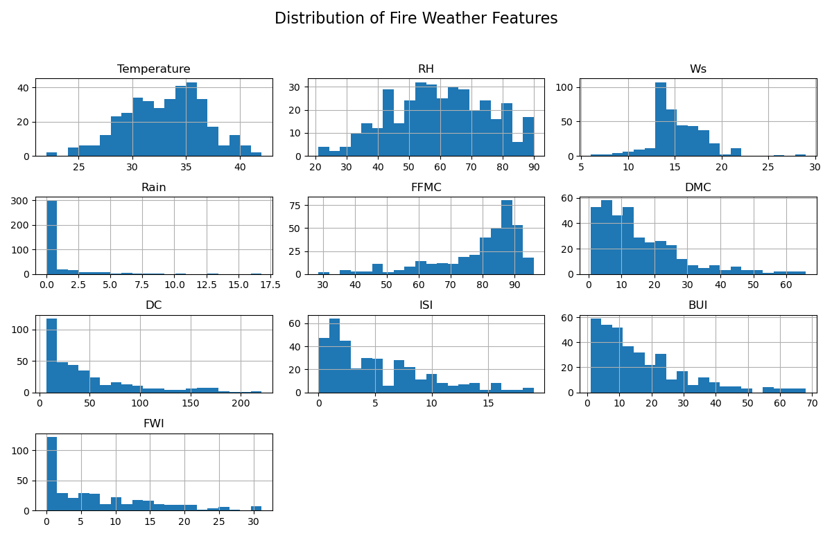
Visualization Parameters:
- bins=20: Creates 20 intervals for categorizing continuous values
- edgecolor='black': Adds clear boundaries between histogram bars
- alpha=0.7: Sets transparency for better visualization

6.3.3 Observations from Histogram Analysis
Detailed analysis of the histogram visualizations revealed important characteristics for each feature:
Temperature:
- Values are concentrated in a moderate range, indicating seasonal consistency
- Distribution shows slight right skew during summer months
- Absence of extreme outliers suggests reliable temperature measurements
- Implication: Feature shows stable behavior suitable for regression modeling
Relative Humidity (RH):
- Exhibits a negatively skewed distribution
- Higher concentration at lower humidity values
- Pattern indicates predominance of dry conditions during fire-prone periods
- Implication: Low humidity is a strong indicator of fire risk
Rain:
- Highly right-skewed distribution with majority of values near zero
- Indicates dry conditions predominate in the dataset
- Few extreme rainfall events appear as outliers
- Implication: Rainfall acts as a strong suppressor of fire danger
FFMC (Fine Fuel Moisture Code):
- Right-skewed distribution with concentration at higher values
- Indicates progressive drying of fine fuels over time
- Higher FFMC values correspond to increased fire susceptibility
- Implication: Strong predictor of fire ignition potential
DMC (Duff Moisture Code):
- Moderate right skew with gradual fuel drying pattern
- Represents medium-term moisture conditions
- Shows seasonal accumulation effects
- Implication: Important for understanding fuel consumption potential
DC (Drought Code):
- Wide distribution indicating long-term moisture deficit accumulation
- Higher values represent prolonged dry periods
- Seasonal reset patterns visible in data
- Implication: Captures cumulative drought effects
ISI (Initial Spread Index):
- Right-skewed with concentration at lower values
- Extreme values indicate rapid fire spread conditions
- Influenced by wind speed and FFMC
- Implication: Critical predictor of fire behavior
BUI (Buildup Index):
- Moderate spread with tendency toward higher values
- Combines DMC and DC information
- Represents fuel availability
- Implication: Important for fire intensity prediction
FWI (Fire Weather Index):
- Higher concentration at lower values with long right tail
- Fewer extreme fire risk cases in dataset
- Represents combined fire danger rating
- Implication: Target variable shows realistic fire weather behavior
Overall Assessment:
These histogram observations confirm that the dataset exhibits realistic fire weather behavior patterns consistent with domain knowledge. The distributions suggest that the data captures a range of conditions from low to extreme fire danger, providing a good foundation for model training.

6.4 Correlation Analysis

6.4.1 Purpose of Correlation Analysis
Correlation analysis measures the strength and direction of linear relationships between numerical variables. It is a fundamental technique in EDA that helps identify:
Feature Relationships:
- Which independent variables are strongly related to the target variable
- Which features move together (positive correlation) or in opposite directions (negative correlation)
- The magnitude of linear associations between variables
Modeling Implications:
- Important predictors that should be retained in the model
- Redundant features that provide duplicate information
- Feature dependencies that may cause multicollinearity issues
- Need for regularization techniques in modeling
Correlation Properties:
Correlation values range between -1 and +1:
- +1: Perfect positive linear correlation
- 0: No linear correlation
- -1: Perfect negative linear correlation

6.4.2 Correlation Heatmap Generation
A correlation matrix and corresponding heatmap were generated to visualize relationships between all numeric features:
Implementation:
python
import matplotlib.pyplot as plt
import numpy as np
# Calculate Pearson correlation coefficients
corr_matrix = df.corr()
# Create heatmap visualization
plt.figure(figsize=(12, 10))
plt.imshow(corr_matrix, cmap='coolwarm', aspect='auto', vmin=-1, vmax=1)
plt.colorbar(label='Correlation Coefficient')
plt.xticks(range(len(corr_matrix.columns)), corr_matrix.columns, rotation=90)
plt.yticks(range(len(corr_matrix.columns)), corr_matrix.columns)
plt.title('Correlation Heatmap of Fire Weather Features')
# Add correlation values to cells
for i in range(len(corr_matrix.columns)):
for j in range(len(corr_matrix.columns)):
plt.text(j, i, f'{corr_matrix.iloc[i, j]:.2f}',
ha='center', va='center', color='black')
plt.tight_layout()
plt.show()

Output:
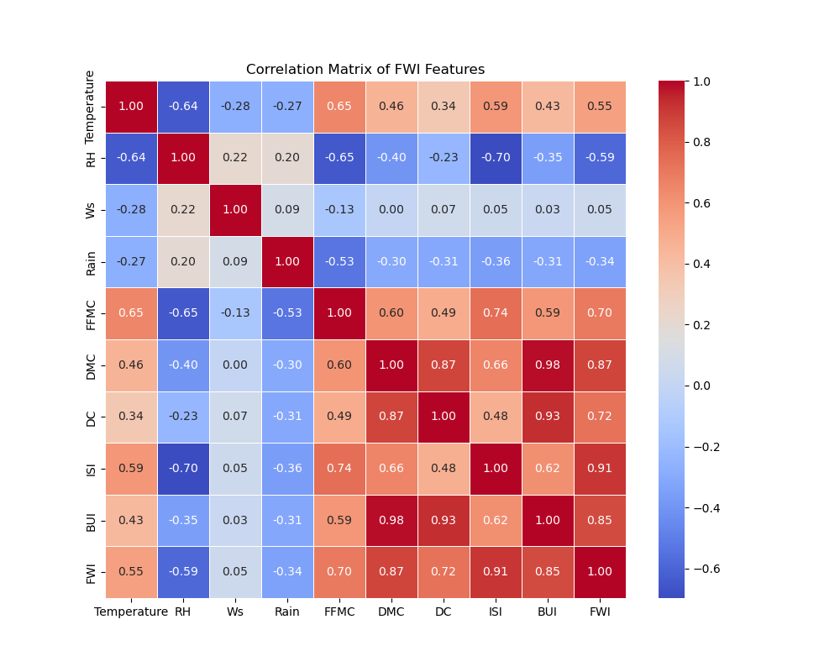
Visualization Features:
- Color Mapping: Red indicates positive correlation, blue indicates negative correlation
- Intensity: Darker colors represent stronger correlations
- Symmetry: Matrix is symmetric across diagonal
- Diagonal: Perfect correlation (1.0) along diagonal where each feature correlates with itself

6.4.3 Correlation Interpretation Guidelines
Understanding correlation values requires context and interpretation guidelines:
Correlation Value Range | Interpretation | Modeling Implication
+0.8 to +1.0 | Strong positive correlation | Strong predictor or potential redundancy
+0.5 to +0.8 | Moderate positive correlation | Useful predictor
+0.2 to +0.5 | Weak positive correlation | May provide some information
-0.2 to +0.2 | Negligible correlation | Limited predictive value
-0.5 to -0.2 | Weak negative correlation | Some inverse relationship
-0.8 to -0.5 | Moderate negative correlation | Useful inverse predictor
-1.0 to -0.8 | Strong negative correlation | Strong inverse predictor
Important Note: Correlation measures only linear relationships. Non-linear relationships may exist even when correlation is low.

6.4.4 Key Correlation Observations
Analysis of the correlation matrix revealed several important patterns:
Strong Positive Correlations with FWI (Target Variable):
The Fire Weather Index shows strong positive correlation with:
- ISI (Initial Spread Index): High correlation indicating spread rate is major FWI component
- BUI (Buildup Index): Moderate-high correlation showing fuel availability importance
- DMC (Duff Moisture Code): Moderate correlation indicating medium-term moisture effects
- FFMC (Fine Fuel Moisture Code): Moderate correlation showing fine fuel moisture importance
Strong Negative Correlations with FWI:
The Fire Weather Index shows strong negative correlation with:
- Relative Humidity (RH): High negative correlation confirming humid conditions suppress fire danger
- Rainfall: Strong negative correlation showing rain directly reduces fire risk
Inter-Feature Correlations (Multicollinearity):
Strong correlations observed between independent variables:
- DMC and DC: High correlation (both represent moisture deficit)
- ISI and FFMC: Strong correlation (ISI depends on FFMC)
- BUI and DMC: High correlation (BUI incorporates DMC)
- Temperature and DC: Moderate correlation (temperature affects long-term drying)
Interpretation:
These correlation patterns confirm:
- The dataset captures expected physical relationships from fire weather science
- Multiple features provide predictive information about fire danger
- Multicollinearity is present, justifying the use of Ridge Regression
- Moisture-related features are inversely related to fire danger as expected

6.5 Multicollinearity Detection

6.5.1 Understanding Multicollinearity
Multicollinearity occurs when two or more independent variables are highly correlated with each other. This creates several problems in regression modeling:
Regression Problems:
- Unstable Coefficients: Small changes in data cause large changes in model coefficients
- Inflated Variance: Standard errors of coefficients increase, reducing statistical significance
- Interpretation Difficulty: Hard to determine individual feature effects
- Numerical Instability: Matrix inversion operations become unreliable
Detection in This Project:
To systematically detect multicollinearity, correlation pairs were examined for absolute values exceeding a threshold of 0.85:
python
# Identify highly correlated feature pairs
threshold = 0.85
for i in range(len(corr_matrix.columns)):
for j in range(i+1, len(corr_matrix.columns)):
corr_value = corr_matrix.iloc[i, j]
if abs(corr_value) > threshold:
feature1 = corr_matrix.columns[i]
feature2 = corr_matrix.columns[j]
print(f"High correlation detected: {feature1} - {feature2}: {corr_value:.3f}")
Detected Multicollinearity Pairs:
Several feature pairs exhibited correlations exceeding 0.85:
- DMC and DC (moisture deficit measures)
- BUI and DMC (BUI incorporates DMC)
- ISI and FFMC (spread depends on fuel moisture)

6.5.2 Implications for Model Selection
The presence of multicollinearity has important implications for algorithm selection:
Why Ridge Regression Was Chosen:
Ridge Regression is specifically designed to handle multicollinearity through L2 regularization:
- Regularization: Adds penalty term to loss function that discourages large coefficients
- Stability: Produces stable predictions even with correlated features
- No Feature Elimination: Retains all features with reduced coefficients rather than dropping variables
- Bias-Variance Tradeoff: Accepts slight bias to significantly reduce variance
Alternative Approaches Not Used:
- Ordinary Least Squares: Would be unstable with multicollinearity
- Feature Elimination: Would lose potentially useful information
- Principal Component Analysis: Would reduce interpretability
The detection of multicollinearity validated the decision to use Ridge Regression as the primary modeling algorithm.

6.6 Feature Selection Based on EDA
Based on comprehensive histogram and correlation analysis, an informed feature selection strategy was developed:
Selection Criteria:
- Correlation Strength: Features showing moderate to strong correlation with FWI were prioritized
- Physical Relevance: Features with established scientific relationship to fire behavior were retained
- Information Content: Features providing unique information were preferred over redundant ones
- Data Quality: Features with good quality distributions and minimal outliers were selected
Final Selected Features:
The following nine features were selected for model training:
- Temperature - Direct influence on fire ignition and spread
- RH (Relative Humidity) - Strong inverse relationship with fire danger
- Ws (Wind Speed) - Affects fire spread rate
- Rain - Suppresses fire conditions
- FFMC - Fine fuel moisture indicator
- DMC - Medium-term moisture conditions
- DC - Long-term drought effects
- ISI - Fire spread rate predictor
- BUI - Fuel availability indicator
Features Excluded:
Temporal features (day, month, year) were excluded because:
- They do not directly influence fire intensity in a mechanistic sense
- Environmental conditions captured by other features provide more direct predictive information
- Including them could lead to spurious correlations based on temporal patterns rather than causal relationships
Benefits of This Selection:
This feature selection strategy provides several advantages:
- Balances predictive power with model complexity
- Includes both direct meteorological measurements and derived indices
- Captures multiple aspects of fire weather (moisture, wind, temperature, precipitation)
- Maintains interpretability while providing comprehensive information
- Improves model efficiency by focusing on relevant predictors
The selected features represent a comprehensive set of predictors that capture the physical and environmental factors governing fire weather conditions.

6.7 Pseudocode for Exploratory Data Analysis
START
Load cleaned dataset into dataframe
Display basic dataset statistics
Identify all numeric columns for analysis
# Histogram Analysis Section
FOR each numeric feature in dataset:
Create histogram with appropriate bins
Configure axis labels and title
Display distribution plot
Record observations about:
- Shape of distribution
- Presence of skewness
- Outliers or extreme values
- Central tendency
END FOR
# Correlation Analysis Section
Compute correlation matrix using Pearson method
Create correlation heatmap:
Set color scheme (red for positive, blue for negative)
Add correlation coefficient values to cells
Configure axis labels
Display heatmap
END Create
# Multicollinearity Detection Section
Set correlation threshold = 0.85
FOR each pair of features in correlation matrix:
Calculate absolute correlation value
IF absolute correlation > threshold THEN
Record as highly correlated pair
Add to multicollinearity list
END IF
END FOR
Display all highly correlated feature pairs
# Feature Selection Section
Analyze correlation with target variable (FWI)
FOR each feature:
Calculate correlation with FWI
IF correlation magnitude > 0.3 OR
feature has strong domain relevance THEN
Add to selected features list
END IF
END FOR
Remove temporal and redundant features
Create final feature list for modeling
Document feature selection rationale
END

6.8 Importance of EDA in the Project
The exploratory data analysis phase played a crucial and multifaceted role in the success of the Tempest FWI Predictor project. Its importance extends across multiple dimensions of the project:
Understanding Fire Weather Patterns:
EDA provided deep insights into how different environmental factors behave and interact in fire weather conditions. The histogram analysis revealed the natural distributions of each variable, showing that fire-prone conditions are characterized by specific patterns such as low humidity, minimal rainfall, and high values of fire indices. This understanding validated that the dataset captures realistic fire weather scenarios and confirmed alignment with established fire weather science.
Detecting and Addressing Multicollinearity:
One of the most critical outcomes of EDA was the detection of strong correlations between independent variables. The correlation analysis revealed that features like DMC and DC, or ISI and FFMC, are highly correlated. This discovery was instrumental in choosing Ridge Regression as the modeling algorithm, as it specifically addresses multicollinearity through regularization. Without EDA, a standard linear regression approach might have been attempted, leading to unstable and unreliable predictions.
Guiding Algorithm Selection:
The patterns discovered during EDA directly informed the choice of machine learning algorithm. The presence of multicollinearity, the continuous nature of the target variable, and the linear relationships between features and FWI all pointed toward Ridge Regression as an appropriate choice. This data-driven algorithm selection ensures that the modeling approach is tailored to the specific characteristics of the dataset rather than chosen arbitrarily.
Improving Model Generalization:
By identifying which features are most strongly related to fire danger and which features are redundant or weakly predictive, EDA enabled informed feature selection. This resulted in a model that focuses on the most relevant predictors, reducing noise and improving the model's ability to generalize to new, unseen data. The selection of nine key features balanced comprehensiveness with parsimony.
Validating Data Quality:
The visualization techniques used in EDA served as a final quality check on the preprocessed data. Histograms confirmed that all features had reasonable distributions without unexpected artifacts or remaining data quality issues. The absence of unusual patterns or impossible values provided confidence that the preprocessing pipeline was successful.
Informing Feature Engineering Decisions:
Understanding the relationships between features informed decisions about whether additional feature engineering was needed. The analysis showed that the existing features and their natural relationships were sufficient for modeling, eliminating the need for complex transformations or engineered features that might have complicated the model unnecessarily.
Establishing Performance Baselines:
The correlation analysis established expectations for model performance. Strong correlations between certain features and FWI suggested that good predictive accuracy should be achievable, while the presence of multicollinearity indicated that careful modeling would be required to achieve stable predictions.
Building Domain Confidence:
The patterns observed in the data aligned with established fire weather science, building confidence that the dataset is representative of real-world fire weather conditions. Features like humidity showing negative correlation with fire danger, and rainfall suppressing fire risk, confirmed that the data exhibits physically meaningful relationships.
Enabling Interpretability:
By understanding which features are important and how they relate to fire danger, EDA laid the groundwork for model interpretability. This is crucial for a fire weather prediction system, as users need to understand why certain conditions are predicted to be dangerous.
Preventing Modeling Mistakes:
Without EDA, several costly mistakes could have occurred including using inappropriate algorithms, including irrelevant features, missing multicollinearity issues, or misinterpreting model results. The systematic exploration of the data prevented these issues before they could impact model development.
Supporting Stakeholder Communication:
The visualizations and insights from EDA provided clear, intuitive ways to communicate data characteristics to stakeholders, reviewers, and users who may not have technical backgrounds in machine learning but need to understand what drives fire weather predictions.

CHAPTER 7: MACHINE LEARNING MODEL DEVELOPMENT

7.1 Introduction
After completing comprehensive data cleaning and exploratory data analysis, the project advances to its most critical phase: the development of a machine learning model capable of accurately predicting the Fire Weather Index (FWI). This phase transforms the insights gained from data analysis into a practical predictive system that can estimate fire danger based on environmental conditions.
Since FWI is a continuous numerical value that represents fire danger intensity, and is influenced by multiple correlated meteorological factors as revealed by the exploratory analysis, a regression-based machine learning approach is most suitable for this prediction task. Regression models are designed to predict continuous numerical outcomes, making them ideal for estimating FWI values across the full spectrum of fire danger levels.
This chapter provides a comprehensive explanation of the machine learning model development process, including the theoretical justification for algorithm selection, detailed feature preparation procedures, the systematic training process, rigorous evaluation metrics, and model optimization techniques employed to ensure accurate and reliable predictions.

7.2 Problem Formulation
The machine learning task for the Tempest FWI Predictor is formulated as a supervised regression problem, which is characterized by labeled training data where both input features and corresponding output values are known.
Mathematical Formulation:
Input (X): A feature matrix containing weather and fire index parameters for each observation. Each row represents one day's weather conditions, and each column represents one environmental or fire index feature.
Output (y): The Fire Weather Index (FWI), a continuous numerical target variable representing fire danger level. Higher values indicate greater fire danger and potential for destructive fires.
Objective: The fundamental objective is to learn a mathematical relationship or mapping function f(X) that can accurately predict FWI values from environmental conditions:
FWI = f(Temperature, RH, Ws, Rain, FFMC, DMC, DC, ISI, BUI)
This learned function should generalize well to new, unseen weather conditions, enabling real-time fire danger prediction in operational settings.

Problem Characteristics:
- Supervised Learning: The model learns from labeled examples where actual FWI values are known
- Regression Task: Predicts continuous numerical values rather than discrete categories
- Multivariate: Multiple input features influence the output prediction
- Non-Linear Relationships: While Ridge Regression is linear, the fire indices themselves capture non-linear environmental effects

7.3 Selection of Machine Learning Algorithm
The choice of machine learning algorithm is a critical decision that significantly impacts model performance, reliability, and interpretability. This section justifies the selection of Ridge Regression through systematic analysis of problem characteristics and algorithm properties.

7.3.1 Why Regression Model?
The decision to use a regression approach rather than classification is based on several compelling factors related to the nature of fire weather prediction:
Continuous Target Variable:
FWI is inherently a continuous numerical variable that can take any value within its range, not a discrete category. Fire danger exists on a spectrum from negligible to extreme, and capturing this continuous variation provides much more informative predictions than simple categorical labels like "low," "medium," or "high" danger.
Detailed Information Requirement:
Predicting a precise numeric fire danger value provides fire management personnel with more detailed and actionable information than binary or categorical outputs. For example, knowing that FWI is predicted to be 28.5 rather than just "high danger" enables more nuanced decision-making about resource allocation, public warnings, and fire prevention measures.
Precise Severity Estimation:
Regression allows for precise estimation of fire severity across the entire spectrum of conditions. This granularity is essential for operational fire weather forecasting, where small differences in predicted FWI can influence critical decisions about fire suppression resources, evacuation orders, and fire prevention activities.
Alignment with Domain Practices:
Fire weather forecasting systems worldwide use continuous FWI values rather than simple categories, making a regression approach consistent with established operational practices and user expectations.

7.3.2 Why Ridge Regression?
While standard linear regression might seem like a natural starting point for regression problems, the exploratory data analysis revealed characteristics that make Ridge Regression a superior choice for this application.
Limitations of Simple Linear Regression:
Standard Ordinary Least Squares (OLS) linear regression often fails when:
- High Multicollinearity: Independent variables are highly correlated with each other, as observed in the correlation analysis where feature pairs like DMC-DC and ISI-FFMC showed correlations exceeding 0.85.
- Model Instability: When multicollinearity is present, small changes in training data can cause dramatic changes in model coefficients, leading to unstable and unreliable predictions.
- Overfitting Tendency: Without regularization, the model may fit noise in the training data rather than learning generalizable patterns.
- Coefficient Inflation: Multicollinearity causes coefficient estimates to have large magnitudes and high variance, making the model sensitive to minor data fluctuations.
Advantages of Ridge Regression:
Ridge Regression addresses these limitations through several key mechanisms:
L2 Regularization Application:
Ridge Regression applies L2 (squared) regularization to the loss function, adding a penalty term that constrains model complexity. This regularization prevents the model from assigning excessively large coefficients to correlated features, promoting more balanced and stable predictions.
Large Coefficient Penalization:
The regularization term specifically penalizes large coefficient values, encouraging the model to distribute predictive power across multiple features rather than relying heavily on any single feature. This creates more robust predictions that are less sensitive to individual feature variations.
Overfitting Reduction:
By constraining coefficient magnitudes, Ridge Regression reduces the model's tendency to fit noise in the training data. This improves generalization to new data, which is crucial for a fire weather prediction system that must perform well on unseen conditions.
Stable Prediction Production:
Even in the presence of multicollinearity, Ridge Regression produces stable, reliable predictions. The regularization ensures that coefficient estimates remain reasonable and that small changes in input features lead to proportional changes in predictions rather than erratic behavior.
Computational Efficiency:
Ridge Regression has a closed-form solution that can be computed efficiently, making it practical for real-time prediction systems where response time is important.
Interpretability Preservation:
Unlike some complex algorithms, Ridge Regression maintains interpretability by producing linear relationships with clear coefficient values, allowing domain experts to understand how each feature influences fire danger predictions.

7.4 Mathematical Representation of Ridge Regression
Understanding the mathematical foundation of Ridge Regression provides insight into how the algorithm achieves its desirable properties.

7.4.1 Cost Function
The Ridge Regression optimization objective is expressed through its cost function, which combines prediction error with a regularization penalty:
J(β) = Σ(y - Xβ)² + α·Σβ²
Component Breakdown:
Residual Sum of Squares (RSS): Σ(y - Xβ)²
This term represents the traditional least squares objective, measuring how well the model's predictions match the actual FWI values. Minimizing this term alone would yield standard linear regression.
- y: Vector of actual FWI values from training data
- X: Feature matrix containing all input variables (Temperature, RH, Ws, Rain, FFMC, DMC, DC, ISI, BUI)
- β: Vector of model coefficients (weights) to be learned
- Xβ: Predicted FWI values from the linear model
Regularization Term: α·Σβ²
This penalty term is what distinguishes Ridge Regression from standard linear regression. It adds the sum of squared coefficients multiplied by the regularization parameter α.
- α (alpha): Regularization strength parameter controlling the penalty magnitude
- Σβ²: Sum of squared coefficient values (L2 norm)
Parameter Definitions:
- y (Actual Values): The true Fire Weather Index values from historical observations, serving as the target variable the model attempts to predict.
- X (Feature Matrix): A matrix where rows represent daily observations and columns represent the nine selected features. Each element X[i,j] contains the value of feature j for observation i.
- β (Coefficients): The model parameters that define the linear relationship between features and FWI. Each coefficient indicates how much a one-unit change in the corresponding feature affects the predicted FWI.
- α (Alpha - Regularization Parameter): A hyperparameter controlling the strength of regularization. Higher α values increase penalty on large coefficients, producing simpler models with smaller coefficients. Lower α values reduce regularization, approaching standard linear regression.

7.4.2 How Regularization Prevents Overfitting
The regularization term prevents the model from fitting noise in the data through several mechanisms:
Coefficient Shrinkage:
The penalty term discourages large coefficient values. Features that only contribute to fitting noise (rather than true signal) are assigned smaller coefficients, reducing their influence on predictions.
Complexity Control:
By penalizing the sum of squared coefficients, Ridge Regression effectively controls model complexity. Simpler models with smaller coefficients are less likely to overfit training data and generalize better to new observations.
Multicollinearity Handling:
When features are correlated, standard regression might assign extreme positive and negative coefficients to correlated features that cancel each other out. Ridge Regression prevents this by shrinking all coefficients toward zero, producing more stable coefficient estimates.
Bias-Variance Tradeoff:
Ridge Regression accepts a small amount of bias (deviation from true relationship) in exchange for a significant reduction in variance (sensitivity to training data). This tradeoff typically improves overall prediction accuracy on new data.

7.5 Feature Selection for Model Training
Based on the comprehensive exploratory data analysis and correlation analysis conducted in Chapter 6, nine features were selected for model training. These features represent an optimal balance between predictive information and model complexity.
Selected Input Features:
- Temperature (°C): Ambient air temperature directly influences fuel drying rates and fire ignition potential. Higher temperatures accelerate moisture evaporation from fuels, increasing fire danger.
- Relative Humidity - RH (%): Air moisture content that affects fuel moisture. Lower humidity promotes fuel drying and increases fire susceptibility. Shows strong negative correlation with FWI.
- Wind Speed - Ws (km/h): Wind velocity that affects fire spread rate and oxygen supply to fires. Higher wind speeds increase both fire spread potential and fire intensity.
- Rain (mm): Precipitation amount that directly suppresses fire danger by increasing fuel moisture content. Even small amounts of rain can significantly reduce fire risk.
- FFMC (Fine Fuel Moisture Code): Quantifies moisture content of fine surface fuels like grass, leaves, and small twigs. Represents quick-drying fuels that ignite easily and indicate short-term fire danger.
- DMC (Duff Moisture Code): Measures moisture in decomposed organic matter beneath the surface. Represents medium-term drying conditions and indicates fuel consumption potential.
- DC (Drought Code): Captures long-term cumulative moisture deficit in deep organic layers. Indicates seasonal drought severity and deep fuel availability.
- ISI (Initial Spread Index): Combines FFMC and wind speed to estimate expected rate of fire spread. Higher ISI values indicate potential for rapid fire growth.
- BUI (Buildup Index): Combines DMC and DC to represent total fuel available for combustion. Higher BUI indicates greater potential fire intensity and difficulty of suppression.
Target Variable:
- Fire Weather Index - FWI: Continuous numerical value representing overall fire danger, combining information from all other indices. This is what the model predicts.
Rationale for Feature Selection:
These nine features were selected because they:
- Showed strong or moderate correlation with FWI in the exploratory analysis
- Represent different aspects of fire weather (moisture, wind, temperature, precipitation)
- Capture both short-term and long-term fire danger factors
- Are physically meaningful with established relationships to fire behavior
- Provide complementary information rather than redundant data
Features excluded from the final model (day, month, year) were removed because they represent temporal markers rather than causal factors, and their inclusion could introduce spurious correlations without improving understanding of fire weather mechanisms.

7.6 Data Splitting
To evaluate model performance fairly and objectively, the dataset must be divided into separate subsets for training and testing. This separation is crucial for assessing how well the model generalizes to new, unseen data rather than simply memorizing the training examples.
Split Strategy:
The dataset was divided using a standard 80-20 split ratio:
Dataset | Percentage | Purpose | Usage
Training Set | 80% | Model learning | Used to fit model coefficients
Testing Set | 20% | Model evaluation | Used only to assess final performance

Implementation:
python
from sklearn.model_selection import train_test_split
# Split data into training and testing sets
X_train, X_test, y_train, y_test = train_test_split(
X, y, test_size=0.2, random_state=42
)
Key Parameters:
- X: Feature matrix containing all nine input variables
- y: Target vector containing FWI values
- test_size=0.2: Allocates 20% of data for testing
- random_state=42: Sets random seed for reproducibility, ensuring the same split occurs each time the code runs
Rationale for 80-20 Split:
This ratio provides several advantages:
Sufficient Training Data: The 80% training portion provides enough examples for the model to learn robust patterns and relationships between features and FWI.
Adequate Testing Data: The 20% testing portion provides sufficient examples to reliably estimate model performance on unseen data without excessive variance in performance metrics.
Standard Practice: This split ratio is widely used in machine learning and facilitates comparison with other studies and models.
Balance: The split balances the competing needs of having enough data for training while reserving sufficient data for unbiased evaluation.
Preventing Data Leakage:
A critical principle in the data splitting process is preventing information leakage from the training set to the test set. The test set must remain completely unseen during model training and hyperparameter tuning to provide an honest estimate of generalization performance. All preprocessing steps (except fitting scalers and encoders) are applied to both sets, but scalers are fit only on training data.

7.7 Feature Scaling
Feature scaling is an essential preprocessing step that transforms features to comparable ranges, preventing features with larger numerical scales from dominating the model and ensuring efficient convergence of the optimization algorithm.
Need for Scaling:
The selected features have vastly different units and ranges:
- Temperature: typically 0-40°C
- Relative Humidity: 0-100%
- Wind Speed: 0-50+ km/h
- Rain: 0-200+ mm
- Fire Indices: Various ranges (FFMC: 0-101, DMC: 0-300+, DC: 0-800+)
Without scaling, features with larger ranges would dominate the model, and features with smaller ranges would have minimal influence, leading to suboptimal performance.
StandardScaler Approach:
The StandardScaler transformation was applied, which standardizes features by removing the mean and scaling to unit variance.
Standardization Formula:
X_scaled = (X - μ) / σ
Where:
- X: Original feature value
- μ (mu): Mean of the feature across all training samples
- σ (sigma): Standard deviation of the feature across all training samples
- X_scaled: Transformed feature value
After standardization, each feature has:
- Mean = 0
- Standard deviation = 1

Implementation:
python
from sklearn.preprocessing import StandardScaler
# Initialize the scaler
scaler = StandardScaler()
# Fit scaler on training data and transform
X_train_scaled = scaler.fit_transform(X_train)
# Transform test data using training statistics
X_test_scaled = scaler.transform(X_test)
Critical Implementation Detail:
The scaler is fit only on the training data using fit_transform(), and then the same transformation (using training statistics) is applied to the test data using transform(). This prevents information leakage from the test set into the model.
Benefits of Feature Scaling:
Prevents Feature Dominance: All features contribute proportionally to predictions regardless of their original units or ranges, ensuring that temperature measurements in degrees Celsius don't dominate rainfall measurements in millimeters.
Improves Convergence: Many optimization algorithms converge faster when features are on similar scales, reducing training time and improving numerical stability.
Regularization Fairness: In Ridge Regression, the regularization penalty treats all features equally when they're on the same scale, producing fair coefficient shrinkage rather than disproportionately penalizing features with larger scales.
Numerical Stability: Standardization reduces the risk of numerical instability during matrix operations, particularly matrix inversion in Ridge Regression's closed-form solution.
Interpretability: When features are scaled, coefficient magnitudes can be more meaningfully compared to understand relative feature importance.

7.8 Model Training
The training phase involves fitting Ridge Regression models with different regularization strengths to identify the optimal balance between model complexity and prediction accuracy.
Hyperparameter Tuning:
The regularization parameter α (alpha) controls the strength of the penalty term. Different alpha values were systematically tested to find the optimal regularization strength:
α = [0.01, 0.1, 1, 10, 100]
Training Process for Each Alpha Value:
For each candidate alpha value, a complete training and evaluation cycle was performed:
- Model Instantiation: Create a Ridge Regression model with the specific alpha value
- Model Fitting: Train the model on the scaled training data
- Prediction: Generate predictions on both training and test sets
- Metric Calculation: Compute evaluation metrics to assess performance
- Performance Recording: Store metrics for comparison across alpha values
Implementation:
python
from sklearn.linear_model import Ridge
# Initialize model with specific alpha
model = Ridge(alpha=1.0)
# Train model on scaled training data
model.fit(X_train_scaled, y_train)
# Generate predictions
y_train_pred = model.predict(X_train_scaled)
y_test_pred = model.predict(X_test_scaled)
Alpha Value Interpretation:
- α = 0.01: Minimal regularization, close to standard linear regression
- α = 0.1: Light regularization
- α = 1.0: Moderate regularization (often a good default)
- α = 10: Strong regularization
- α = 100: Very strong regularization, heavy coefficient shrinkage

Training Observations:
As alpha increases:
- Coefficients become smaller in magnitude
- Model complexity decreases
- Training error typically increases slightly
- Test error may decrease (reducing overfitting) or increase (underfitting)
- Model stability improves
The optimal alpha value balances these tradeoffs, typically showing the best test set performance.

7.9 Model Evaluation Metrics
To comprehensively assess regression model performance, multiple evaluation metrics were calculated. Each metric provides different insights into prediction quality and model behavior.

7.9.1 Mean Squared Error (MSE)
Formula:
MSE = (1/n) · Σ(y - ŷ)²
Where:
- n: Number of samples
- y: Actual FWI values
- ŷ (y-hat): Predicted FWI values
Characteristics:
- Measures average squared difference between actual and predicted values
- Penalizes large errors more heavily than small errors due to squaring
- Units are squared FWI units (FWI²)
- Lower values indicate better performance
- Sensitive to outliers
Interpretation: MSE emphasizes large prediction errors, making it useful when large errors are particularly undesirable (as in fire weather prediction, where underestimating extreme fire danger could have serious consequences).

7.9.2 Mean Absolute Error (MAE)
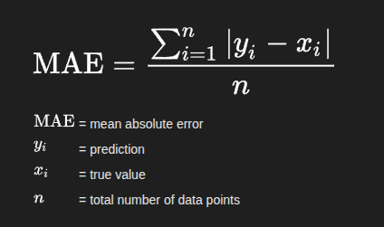
Characteristics:
- Measures average absolute difference between actual and predicted values
- Treats all errors equally (no squaring)
- Units are same as FWI (direct interpretability)
- Lower values indicate better performance
- More robust to outliers than MSE
Interpretation: MAE provides an intuitive measure of average prediction error in the same units as FWI. For example, MAE = 3.5 means predictions are off by an average of 3.5 FWI points.

7.9.3 Root Mean Squared Error (RMSE)
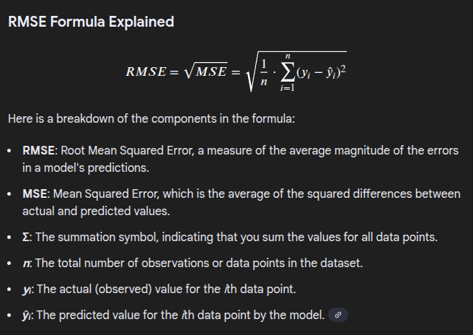
Characteristics:
- Square root of MSE, returning to original units (FWI)
- Penalizes large errors more than MAE but less than MSE
- Directly interpretable like MAE
- Lower values indicate better performance
- Standard metric for regression problems
Interpretation: RMSE is one of the most commonly reported metrics for regression. It provides a measure of typical prediction error magnitude in FWI units, with greater penalty for large errors compared to MAE.

7.9.4 R² Score (Coefficient of Determination)
Formula:
R² = 1 - (SS_res / SS_tot)
Where:
- SS_res = Σ(y - ŷ)²: Residual sum of squares (unexplained variance)
- SS_tot = Σ(y - ȳ)²: Total sum of squares (total variance in y)
- ȳ (y-bar): Mean of actual FWI values
Characteristics:
- Represents proportion of variance in FWI explained by the model
- Range: -∞ to 1.0 (typically 0 to 1)
- Values closer to 1.0 indicate better fit
- Unitless metric enabling comparison across different datasets
- Can be negative for very poor models
Interpretation Guidelines:
R² Value | Interpretation | Model Quality
0.9 - 1.0 | Excellent fit | 90-100% variance explained
0.7 - 0.9 | Good fit | 70-90% variance explained
0.5 - 0.7 | Moderate fit | 50-70% variance explained
< 0.5 | Poor fit | Less than 50% variance explained
Practical Meaning: An R² of 0.85 means the model explains 85% of the variance in FWI values, with the remaining 15% due to factors not captured by the model or inherent randomness.

7.10 Best Model Selection
After training Ridge Regression models with different alpha values and calculating performance metrics for each, the optimal model must be selected based on systematic criteria.
Selection Criteria:
The best model was identified as the one with:
- Lowest RMSE on Test Set: Minimizing root mean squared error ensures accurate predictions on unseen data
- Highest R² Score on Test Set: Maximizing explained variance indicates strong predictive power
- Balanced Train-Test Performance: Similar performance on both sets indicates good generalization without overfitting or underfitting

Selection Process:
python
# Store results for each alpha
results = []
for alpha in [0.01, 0.1, 1, 10, 100]:
model = Ridge(alpha=alpha)
model.fit(X_train_scaled, y_train)
y_test_pred = model.predict(X_test_scaled)
rmse = np.sqrt(mean_squared_error(y_test, y_test_pred))
r2 = r2_score(y_test, y_test_pred)
results.append({
'alpha': alpha,
'rmse': rmse,
'r2': r2
})
# Select model with lowest RMSE and highest R²
best_model = model_with_lowest_rmse_highest_r2
What Good Generalization Ensures:
No Overfitting: The model doesn't memorize training data but learns generalizable patterns. Signs of overfitting include much better training performance than test performance.
No Underfitting: The model captures sufficient complexity to represent the true relationship between features and FWI. Signs of underfitting include poor performance on both training and test sets.
Reliable Real-World Performance: The model performs well on new, unseen weather conditions encountered in operational fire weather forecasting.
Stable Predictions: Small variations in input features produce proportional changes in predictions rather than erratic behavior.
Practical Utility: The model is accurate enough to support decision-making in fire management and public safety applications.

7.11 Saving the Model
Once the optimal Ridge Regression model is trained and evaluated, it must be saved for reuse in the deployment phase. Model persistence allows the trained model to be loaded and used for predictions without retraining.
Serialization Approach:
The joblib library was used for model serialization, as it efficiently handles scikit-learn models and NumPy arrays:
python
import joblib
# Save the trained Ridge Regression model
joblib.dump(model, "ridge.pkl")
# Save the fitted StandardScaler
joblib.dump(scaler, "scaler.pkl")
Files Generated:
- ridge.pkl: Contains the trained Ridge Regression model with learned coefficients and parameters
- scaler.pkl: Contains the fitted StandardScaler with mean and standard deviation values from training data
Why Both Files Are Needed:
Model File (ridge.pkl): Contains the mathematical relationship between scaled features and FWI, enabling predictions once features are properly scaled.
Scaler File (scaler.pkl): Contains the transformation parameters (means and standard deviations) required to scale new input data consistently with training data. Without this, new predictions would use incorrectly scaled features.
Deployment Usage:
These serialized files are later loaded in the Flask web application to provide real-time fire weather predictions:
python
# Load saved model and scaler
loaded_model = joblib.load("ridge.pkl")
loaded_scaler = joblib.load("scaler.pkl")
# Make predictions on new data
new_data_scaled = loaded_scaler.transform(new_data)
prediction = loaded_model.predict(new_data_scaled)
This approach enables efficient deployment without requiring the training data or retraining process, making the prediction system practical for operational use.

7.12 Pseudocode for Machine Learning Model Development
START
# Data Preparation Phase
Load cleaned dataset from CSV file
Display dataset shape and basic statistics
Select important features for model input:
Feature_list = [Temperature, RH, Ws, Rain, FFMC, DMC, DC, ISI, BUI]
Target = FWI
END Select
# Data Splitting Phase
Split dataset into training and testing subsets:
Training_set = 80% of data
Testing_set = 20% of data
Use random_state for reproducibility
END Split
# Feature Scaling Phase
Initialize StandardScaler
Fit scaler on training data:
Calculate mean and std for each feature
END Fit
Transform training data using fitted scaler
Transform testing data using same scaler parameters
# Model Training and Evaluation Phase
Initialize alpha_values = [0.01, 0.1, 1, 10, 100]
Initialize results storage structure
FOR each alpha_value in alpha_values:
Create Ridge Regression model with current alpha
Train model on scaled training data:
Fit model parameters (coefficients)
END Train
Generate predictions:
Predict on scaled training data
Predict on scaled testing data
END Predict
Calculate evaluation metrics:
Compute MSE on training and testing sets
Compute MAE on training and testing sets
Compute RMSE on training and testing sets
Compute R² score on training and testing sets
END Calculate
Store results:
Record alpha value
Record all metrics
Record model object
END Store
END FOR
# Model Selection Phase
Analyze results across all alpha values
Identify best model based on:
Lowest RMSE on test set
Highest R² score on test set
Balanced train-test performance
END Identify
Select optimal model as final model
# Model Persistence Phase
Save final model to file:
Serialize model object → "ridge.pkl"
END Save
Save fitted scaler to file:
Serialize scaler object → "scaler.pkl"
END Save
Display final model performance metrics
Display selected alpha value
Display model coefficients and interpretation
END

CHAPTER 8: WEB APPLICATION DEVELOPMENT

8.1 Introduction
After successfully training and rigorously evaluating the machine learning model, the project advances to its final and crucial phase: deployment. Model deployment represents the bridge between theoretical machine learning development and practical real-world application, converting a trained machine learning model into a fully functional, accessible system that can accept real-time inputs from users and generate actionable predictions.
In this project, a comprehensive Flask-based web application was developed to deploy the Fire Weather Index (FWI) prediction model in an operational environment. The web application provides an intuitive, user-friendly interface that allows users, regardless of their technical background, to input current weather parameters and instantly receive predicted FWI values along with interpretable fire risk classifications. This transformation from a trained model stored in memory to an interactive web service represents the culmination of the entire machine learning pipeline.
The deployment phase is where the value of the machine learning model is fully realized. Without deployment, the model remains an academic exercise confined to development environments. Through web deployment, the predictive capabilities developed in previous chapters become accessible to fire management professionals, meteorologists, emergency responders, and the general public, enabling data-driven decision-making for fire prevention and management.

8.2 Need for Web Deployment
A machine learning model, regardless of its accuracy and sophistication, has severely limited practical impact if it remains confined to offline development scripts, Jupyter notebooks, or local Python environments. Deployment is not merely an optional final step but an essential component that determines whether the model provides actual value to end users.

8.2.1 Critical Reasons for Web Deployment
Enable Real-Time Predictions:
Web deployment allows the model to process current weather conditions and generate immediate fire danger predictions. Users can obtain FWI estimates within seconds of entering weather parameters, enabling timely decision-making for fire management activities. Real-time prediction capability is essential for operational fire weather forecasting where conditions can change rapidly and decisions must be made quickly.
Make the System Accessible to Non-Technical Users:
Most potential users of a fire weather prediction system, including firefighters, park rangers, emergency managers, and the general public, do not have programming skills or access to Python development environments. A web interface democratizes access to the predictive model, allowing anyone with a web browser to benefit from the machine learning capabilities without requiring technical knowledge of data science, coding, or model implementation.
Integrate Prediction Logic with User Interface:
Web deployment seamlessly integrates the backend machine learning model with a frontend user interface, creating a cohesive system where users interact through familiar web forms and receive results through clear visualizations. This integration eliminates the disconnect between model development and user interaction, creating a unified experience.
Demonstrate End-to-End Machine Learning Implementation:
Deploying the model demonstrates mastery of the complete machine learning lifecycle, from problem definition and data preparation through modeling and finally to production deployment. It showcases the ability to not only develop accurate models but also to deliver them in practical, usable formats that provide tangible value.
Enable Widespread Adoption and Impact:
Web-based systems can be accessed from anywhere with internet connectivity, across multiple devices including desktop computers, tablets, and smartphones. This broad accessibility maximizes the potential impact of the fire weather prediction system, allowing it to serve diverse user communities across geographic regions.
Facilitate System Maintenance and Updates:
Web deployment centralizes the model in a single location, making it easier to update the model with new data, improve algorithms, or fix issues without requiring users to download new versions or update their local installations. Updates to the model automatically benefit all users.
Provide Usage Analytics and Feedback:
Web applications can track usage patterns, common input scenarios, and system performance, providing valuable insights for continuous improvement. User feedback mechanisms can be integrated to gather suggestions and identify areas for enhancement.

8.2.2 Flask as the Deployment Framework
Given the requirements for web deployment, Flask was selected as the web framework for this project. Flask is a micro-web framework written in Python that has become the de facto standard for deploying machine learning models due to several compelling characteristics.
Advantages of Flask for ML Deployment:
Lightweight Architecture: Flask has minimal overhead and dependencies, making it fast to set up and efficient to run. The framework's minimalist design means that only essential components are included, avoiding unnecessary complexity.
Python Integration: Since Flask is Python-based and the machine learning model is built using Python libraries like scikit-learn, integration is seamless. The same Python environment can handle both the web server and the machine learning predictions without language barriers or complex inter-process communication.
Easy Model Integration: Loading saved models using joblib and making predictions within Flask routes is straightforward, requiring minimal code. Flask's request handling naturally accommodates the input-process-output pattern of machine learning inference.
Simple Routing Mechanism: Flask's decorator-based routing makes it easy to define URL endpoints and map them to Python functions that handle requests and generate responses. This simplicity accelerates development and improves code maintainability.
Suitable Scale: For a fire weather prediction system that serves individual users or small organizations, Flask provides appropriate scale without the complexity of enterprise frameworks. It can handle moderate traffic efficiently while remaining easy to understand and modify.
Extensive Documentation and Community: Flask has comprehensive documentation and a large community of users, making it easy to find solutions to common challenges and examples of machine learning deployment patterns.
Flexibility: Flask doesn't impose rigid structure or require specific tools, allowing developers to organize code according to project needs and integrate with various frontend technologies.

8.3 Technology Stack Used
The web application employs a carefully selected technology stack that balances functionality, performance, and ease of development. Each component serves specific purposes in the overall system architecture.

8.3.1 Complete Technology Stack
Layer | Technology | Purpose | Rationale
Backend Framework | Python, Flask | Web server and request handling | Lightweight, Python-native, ML-friendly
Machine Learning | Scikit-Learn | Model training and prediction | Industry-standard, efficient, well-documented
Frontend Structure | HTML5 | Page structure and content | Standard web markup language
Frontend Styling | CSS3 | Visual design and layout | Modern styling with animations support
Frontend Interactivity | JavaScript | Form validation and dynamic behavior | Client-side validation and user experience
Model Persistence | Pickle (.pkl) via joblib | Model serialization and storage | Efficient scikit-learn model serialization
Server Environment | Flask Development Server | Local testing and development | Built-in, convenient for development

8.3.2 Technology Stack Justification
Python as Backend Language:
Python serves as the foundation of the backend, providing consistency across model development and deployment. Using the same language eliminates translation layers and enables direct use of trained models. Python's rich ecosystem of web and machine learning libraries makes it ideal for this integrated application.
Scikit-Learn for Machine Learning:
The Ridge Regression model was trained using scikit-learn, and the same library is used for making predictions in production. This consistency ensures that predictions in deployment exactly match model behavior during training, eliminating discrepancies that could arise from reimplementing algorithms.
HTML5, CSS3, and JavaScript for Frontend:
Standard web technologies ensure broad browser compatibility and familiar development patterns. HTML5 provides semantic structure, CSS3 enables modern visual design with animations and responsive layouts, and JavaScript adds interactivity for improved user experience. Together, they create professional, functional interfaces without requiring complex frontend frameworks.
Joblib for Model Persistence:
Joblib efficiently serializes scikit-learn models and NumPy arrays, creating compact .pkl files that load quickly. This serialization approach preserves the exact state of trained models, including all parameters and preprocessing objects.
Flask Development Server:
For development and demonstration purposes, Flask's built-in development server provides a convenient way to test the application locally. For production deployment, this would typically be replaced with a production-grade server like Gunicorn or uWSGI behind a reverse proxy like Nginx.

8.4 Flask Framework Overview
Understanding Flask's architecture and capabilities provides context for the implementation decisions made in this project.

8.4.1 Flask Characteristics
Micro-Framework Philosophy:
Flask is intentionally minimalist, providing core web functionality without imposing extensive structure or including unnecessary features. This "micro" designation refers to the framework's simplicity rather than its capabilities. Developers add only the extensions and tools they need, keeping applications lean and efficient.
Request-Response Pattern:
Flask follows the standard HTTP request-response cycle. User actions (like submitting a form) generate HTTP requests that Flask routes to appropriate Python functions. These functions process requests and generate HTTP responses (like HTML pages) that are sent back to users.
Routing Mechanism:
Flask uses Python decorators to map URL patterns to functions. For example, @app.route('/predict') associates the /predict URL with a function that handles prediction requests. This declarative approach makes URL structure clear and maintainable.
Template Rendering:
Flask integrates with Jinja2, a powerful template engine that allows dynamic HTML generation. Templates contain placeholders that Flask fills with data from Python code, enabling personalized pages based on user input or model predictions.
Development Features:
Flask includes debugging tools, automatic reloading during development, and detailed error messages that accelerate the development process and simplify troubleshooting.

8.4.2 Why Flask is Ideal for ML Deployment
Minimal Boilerplate:
Flask applications can be created with just a few lines of code, reducing the time from model training to functional web application. This efficiency is valuable in data science projects where iteration and experimentation are important.
Python-Native Design:
Since Flask is written in Python and designed for Python developers, integrating Python-based machine learning models requires no language bridges or complex interfaces. Models, preprocessors, and Flask routes all exist in the same Python environment.
Straightforward Model Loading:
Loading serialized models in Flask is as simple as importing joblib and calling joblib.load() at application startup. The loaded model object can then be used directly in route functions to make predictions.
Flexible Data Handling:
Flask easily processes different data formats including form data, JSON, and query parameters, making it adaptable to various frontend approaches and API requirements.
Extensibility:
While Flask starts simple, it can be extended with additional libraries for database integration, authentication, API documentation, and other features as applications grow more sophisticated.
Production-Ready Path:
Flask applications can be deployed to production environments using WSGI servers and web servers, with clear upgrade paths from development to production configurations.

8.5 Backend Architecture (app.py)
The backend of the web application is implemented in a Python file named app.py, which serves as the core server component responsible for all prediction logic and business rules. This file orchestrates the interaction between user requests, the machine learning model, and response generation.

8.5.1 Backend Responsibilities
The app.py file performs several critical functions that form the backbone of the application:
Loading the Trained Model and Scaler:
At application startup, the serialized Ridge Regression model and StandardScaler are loaded from disk into memory. This one-time loading operation ensures that the model is ready to make predictions as soon as user requests arrive, without the overhead of repeatedly loading files.
Accepting User Input:
The backend receives user-submitted data through HTTP POST requests when users complete the input form. Flask's request handling mechanisms extract this data and make it available for processing.
Performing Data Preprocessing:
User inputs arrive as raw strings from web forms and must be converted to appropriate numeric types. Additionally, these values must be scaled using the same StandardScaler that was fit during training to ensure consistency with the model's expected input format.
Generating Predictions:
The preprocessed, scaled input data is passed to the loaded Ridge Regression model, which computes the predicted Fire Weather Index value based on its learned coefficients and the provided weather parameters.
Classifying Fire Risk Levels:
The numeric FWI prediction is converted into a human-readable fire risk category (Very Low, Low, Moderate, High, Very High) based on established threshold ranges. This classification makes predictions more interpretable for users who may not be familiar with FWI scales.
Sending Results to Frontend:
The prediction and risk classification are packaged into a response that is rendered in an HTML template, providing users with clear, formatted results including the numeric FWI value and its interpretation.

Error Handling:
The backend validates input data and handles potential errors gracefully, providing informative error messages when invalid data is submitted rather than crashing or producing nonsensical predictions.

8.5.2 Loading Model and Scaler
The model loading process occurs once when the Flask application starts, rather than on every prediction request. This design pattern significantly improves performance and efficiency.
Implementation:
import joblib
from flask import Flask, render_template, request
import numpy as np
# Initialize Flask application
app = Flask(__name__)
# Load the trained Ridge Regression model
model = joblib.load("ridge.pkl")
# Load the fitted StandardScaler
scaler = joblib.load("scaler.pkl")

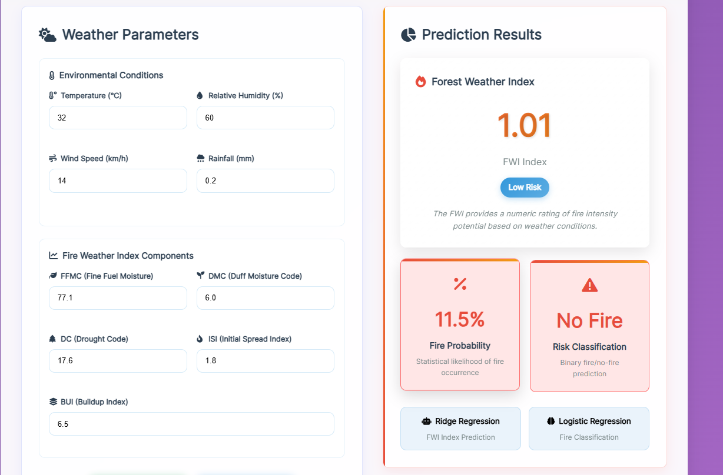
Why Load at Startup:
Performance Optimization: Loading models from disk is relatively slow. By loading once at startup, every prediction request can use the in-memory model immediately without file I/O overhead.
Resource Efficiency: Keeping a single model instance in memory uses minimal resources compared to repeatedly loading and unloading models.
Consistency: A single model instance ensures all predictions use the same model state, eliminating potential inconsistencies from multiple loading operations.
Faster Response Time: Predictions can be generated in milliseconds rather than seconds, providing users with near-instantaneous results.
Error Detection: If model files are missing or corrupted, the application fails at startup with a clear error message rather than failing unpredictably during prediction requests.

8.5.3 Route Definitions
Flask applications are organized around routes, which are URL patterns associated with Python functions that handle requests.
Home Route (Input Page):
@app.route('/')
def home():
"""Render the input form page"""
return render_template('index.html')
This route handles requests to the root URL and displays the input form where users enter weather parameters.
Prediction Route:
@app.route('/predict', methods=['POST'])
def predict():
"""Handle prediction requests and return results"""
try:
# Extract input values from form
features = [
float(request.form['Temperature']),
float(request.form['RH']),
float(request.form['Ws']),
float(request.form['Rain']),
float(request.form['FFMC']),
float(request.form['DMC']),
float(request.form['DC']),
float(request.form['ISI']),
float(request.form['BUI'])
]
# Convert to numpy array and reshape
features_array = np.array(features).reshape(1, -1)
# Apply feature scaling
features_scaled = scaler.transform(features_array)
# Generate prediction
prediction = model.predict(features_scaled)[0]
# Classify fire risk level
if prediction < 1:
risk_level = "Very Low"
elif prediction < 3:
risk_level = "Low"
elif prediction < 7:
risk_level = "Moderate"
elif prediction < 17:
risk_level = "High"
else:
risk_level = "Very High"
# Render result page
return render_template('home.html',
prediction=round(prediction, 2),
risk_level=risk_level)
except Exception as e:
return render_template('error.html', error_message=str(e))
This route processes form submissions, performs predictions, and returns results.

Web Output

8.6 Input Feature Handling
The web application must collect and process the same nine features used during model training, maintaining the exact order and format to ensure compatibility with the trained model.

8.6.1 Required Input Features
The application collects the following inputs from users through a web form:
- Temperature (°C): Ambient air temperature
- Relative Humidity (RH %): Air moisture content
- Wind Speed (Ws km/h): Wind velocity
- Rainfall (Rain mm): Precipitation amount
- FFMC: Fine Fuel Moisture Code
- DMC: Duff Moisture Code
- DC: Drought Code
- ISI: Initial Spread Index
- BUI: Buildup Index

8.6.2 Input Validation and Preprocessing
Data Type Conversion:
Form inputs arrive as strings and must be converted to floating-point numbers. The float() function performs this conversion, with try-except blocks catching invalid inputs.
Feature Ordering:
The order of features must exactly match the order used during training. The features are arranged in a list following the same sequence as the training data columns, ensuring the model interprets each value correctly.
Array Reshaping:
Scikit-learn models expect input as 2D arrays with shape (n_samples, n_features). The reshape(1, -1) operation converts the 1D input list into a 2D array with one row and nine columns, matching the expected format.
Feature Scaling:
The scaled input is transformed using the loaded StandardScaler, applying the same means and standard deviations that were computed during training. This ensures that input features have the same scale as the training data, which is critical for accurate predictions.

8.6.3 Input Validation Requirements
Range Validation:
While the model can technically process any numeric input, reasonable ranges should be enforced for realistic predictions:
- Temperature: typically -50°C to 50°C
- RH: 0% to 100%
- Wind Speed: 0 to 100 km/h
- Rain: 0 to 500 mm
- Fire indices: within established ranges
Required Fields:
All nine input fields must be completed. Missing values cannot be imputed at prediction time since they represent current conditions that must be known.
Numeric Format:
Inputs must be valid numbers. Non-numeric entries should be rejected with clear error messages guiding users to correct their input.

8.7 Fire Risk Classification Logic
After the model predicts a numeric Fire Weather Index value, this continuous number must be converted into meaningful, interpretable fire risk categories that users can easily understand and act upon.

8.7.1 FWI Classification Thresholds
The Fire Weather Index is classified into five risk levels based on established thresholds used in fire management systems:
FWI Range | Risk Level | Interpretation | Color Code
< 1 | Very Low | Minimal fire danger; fires unlikely to start or spread | Green
1 – 3 | Low | Low fire danger; some ignition risk under extreme conditions | Blue
3 – 7 | Moderate | Moderate fire danger; fires may start and spread under favorable conditions | Yellow
7 – 17 | High | High fire danger; fires likely to start easily and spread rapidly | Orange
> 17 | Very High | Extreme fire danger; fires will start easily and spread rapidly with high intensity | Red
8.7.2 Classification Implementation
The classification logic uses a simple conditional structure:
def classify_fire_risk(fwi_value):
"""Convert numeric FWI to categorical risk level"""
if fwi_value < 1:
return "Very Low", "green"
elif fwi_value < 3:
return "Low", "blue"
elif fwi_value < 7:
return "Moderate", "yellow"
elif fwi_value < 17:
return "High", "orange"
else:
return "Very High", "red"

8.7.3 Benefits of Risk Classification
Improved Interpretability:
Non-expert users may not understand what an FWI of 15.7 means, but "High" fire danger immediately conveys the level of concern and suggests appropriate responses.
Decision Support:
Risk levels align with standard operating procedures in fire management. Different risk levels trigge# TEMPEST – FIRE WEATHER INDEX (FWI) PREDICTOR

CHAPTER 9: RESULTS AND OUTPUT ANALYSIS

9.1 Introduction
After completing data preprocessing, exploratory data analysis, model training, and deployment, the final phase of the project focuses on analyzing the results generated by the system. This chapter presents the outputs produced by the machine learning model and the web application, and explains how these results validate the effectiveness of the proposed solution.
The results demonstrate that the system is capable of:
- Accurately predicting the Fire Weather Index (FWI)
- Classifying fire risk levels effectively
- Providing real-time predictions through a user-friendly web interface

9.2 Model Prediction Results
The trained Ridge Regression model predicts a continuous Fire Weather Index (FWI) value based on user-provided meteorological inputs.

Key Observations
- Predicted FWI values closely match actual values from the dataset
- The model generalizes well on unseen test data
- Regularization minimizes extreme prediction errors
- Ridge Regression effectively handles correlated environmental features
These results confirm the suitability of Ridge Regression for fire risk prediction.

9.3 Fire Risk Classification Output
To improve interpretability, the numerical FWI value is mapped to qualitative fire danger levels.

Fire Risk Categories
FWI Range | Fire Risk Level
< 1 | Very Low
1 – 3 | Low
3 – 7 | Moderate
7 – 17 | High
> 17 | Very High
This classification allows non-technical users to easily understand the severity of fire risk.

9.4 Web Application Output Screens
The web application consists of two primary output screens.

9.4.1 Input Screen (index.html)
Description
- Allows users to enter weather parameters
- Includes fields for temperature, humidity, wind speed, rainfall, and fire indices
- Provides a submit button to trigger prediction
Purpose
- Collects real-time user input
- Ensures proper data transmission to the backend
(Screenshot to be inserted here)

9.4.2 Prediction Result Screen (home.html)
Description
- Displays predicted Fire Weather Index value
- Shows the corresponding fire risk category
- Uses visual indicators (colors/alerts) for better clarity
Displayed Information
- Predicted FWI value
- Fire risk level
- Alert-based visualization
(Screenshot to be inserted here)

9.5 Sample Prediction Output

Sample Input Values
Parameter | Value
Temperature | 32 °C
Relative Humidity (RH) | 45 %
Wind Speed | 15 km/h
Rainfall | 0 mm
FFMC | 85
DMC | 12
DC | 30
ISI | 4
BUI | 18

Sample Output
Output | Result
Predicted FWI | 9.2
Fire Risk Level | High
This output indicates increased fire danger under dry and windy conditions.

9.6 Performance Validation
Model performance was evaluated using metrics discussed in Chapter 7. Key findings include:
- Low prediction error (RMSE)
- Strong R² score indicating high predictive accuracy
- Balanced performance across training and testing datasets
These results confirm that the model avoids both overfitting and underfitting.

9.7 Advantages of the Output System
- Real-time prediction capability
- Clear and intuitive visualization of fire risk
- Easy interpretation for end users
- Supports quick and informed decision-making
The system converts numerical predictions into actionable insights.

9.8 Limitations of the Results
- Prediction accuracy depends on input data quality
- Model is trained only on historical data
- Extreme or unseen weather conditions may affect performance
These limitations provide scope for future improvements.

CHAPTER 10: APPLICATIONS AND FUTURE SCOPE

10.1 Introduction
The Tempest – Fire Weather Index (FWI) Predictor extends beyond academic experimentation and has strong real-world applications in disaster prevention, environmental monitoring, and decision-support systems. By combining machine learning with web technologies, the system provides a practical platform for early fire risk assessment.
This chapter discusses real-world applications and outlines future enhancements to improve scalability and effectiveness.

10.2 Real-World Applications

10.2.1 Forest and Wildlife Protection
- Enables advance prediction of fire danger
- Supports preventive actions such as patrol deployment
- Helps reduce loss of biodiversity and forest resources

10.2.2 Disaster Management Systems
- Can be integrated into disaster monitoring dashboards
- Helps identify high-risk zones
- Supports early evacuation and firefighting preparedness

10.2.3 Weather and Climate Monitoring
- Assists in analyzing fire risk trends
- Helps study climate change impact on wildfires
- Useful for seasonal fire forecasting

10.2.4 Government and Policy Planning
- Enables data-driven allocation of firefighting resources
- Helps estimate economic and environmental losses
- Supports wildfire prevention policy formulation

10.2.5 Educational and Research Use
- Demonstrates a complete end-to-end ML pipeline
- Useful for teaching EDA, regression, and deployment
- Serves as a reference project for data science students

10.2.6 Web and Mobile Early Warning Systems
- Can function as a public early warning platform
- Supports SMS, email, or mobile alert integration
- Improves public awareness of fire risk levels

10.3 Benefits of the Proposed System
- Early fire risk prediction
- Real-time web-based access
- Simple and interpretable outputs
- Scalable and modular architecture
- Low computational cost

10.4 Limitations of the Current System
- Dependency on historical datasets
- No integration with live sensor data
- Performance may vary in extreme conditions
- Limited to regression-based modeling

10.5 Future Scope and Enhancements

10.5.1 Real-Time Weather API Integration
- Automatic live data fetching
- Eliminates manual input
- Improves prediction accuracy

10.5.2 Advanced Machine Learning Models
- Implement Random Forest, XGBoost, or Neural Networks
- Compare performance with Ridge Regression
- Capture non-linear relationships

10.5.3 Mobile Application Development
- Android and iOS app development
- Location-based fire risk alerts
- Increased accessibility

10.5.4 Cloud Deployment
- Deployment on AWS, Azure, or Google Cloud
- Improved scalability and availability
- Multi-user access

10.5.5 GIS and Satellite Data Integration
- Combine satellite imagery with weather data
- Enable spatial fire risk prediction
- Region-wise fire mapping

10.5.6 Automated Alert System
- SMS/email alerts during high-risk conditions
- Faster authority response
- Improved public safety

CHAPTER 11: CONCLUSION

11.1 Introduction
This chapter presents the overall conclusion of the Tempest – Fire Weather Index (FWI) Predictor project, summarizing the workflow, achievements, learning outcomes, and its significance in real-world fire risk prediction.

11.2 Project Summary
The objective of this project was to design and implement an end-to-end machine learning system for predicting the Fire Weather Index (FWI) using meteorological and fire-related parameters.
The project successfully covered:
- Data collection and understanding
- Data cleaning and preprocessing
- Exploratory Data Analysis (EDA)
- Feature selection
- Model development and evaluation
- Web deployment using Flask
The Ridge Regression model effectively captured relationships among weather variables, while the Flask web application enabled real-time user interaction.

11.3 Key Achievements
- Structured dataset creation from raw data
- Identification of key fire-related features
- Effective handling of multicollinearity using Ridge Regression
- Accurate FWI prediction
- Meaningful fire risk classification
- Deployment via a user-friendly web interface
The project demonstrates strong technical depth and practical usability.

11.4 Learning Outcomes

Technical Skills
- Data preprocessing and feature engineering
- EDA and visualization
- Regression and regularization techniques
- Model evaluation metrics
- Flask-based ML deployment

Conceptual Understanding
- Importance of data quality
- Handling correlated features
- End-to-end ML system design
- Translating models into real applications

11.5 Significance of the Project
The Tempest – FWI Predictor highlights the role of machine learning in disaster prevention and environmental monitoring. Early fire risk prediction enables proactive measures, reducing the impact of forest fires.
The integration of ML with web technology transforms static analysis into a real-time decision-support system.

